Crime behind the scenes of a mathematical conference - Who killed Mr. X?
Detecting a crime by an inspector mathematician!

The story is played in a hotel where one of the most important conferences of mathematics takes place.
Mr. Mathematician X is alone in the dining room, and prepares his presentation he will make on the next day of the conference.
Meanwhile a waiter enters the dining room and approaches Mr. X. He addresses Mr. X and tells him that dining room closes in a while. Would he like something before the room closes? Only a glass of water, responds Mr. X.
The waiter leaves and returns after a while. And what a surprise!!! Mr. X is dead!!!
The inspector arrives at the hotel and a police officer informs him for the crime. He tells him that there are ten suspects, but because all the suspects are mathematicians, their statements are in mathematical language and cannot understand them. The inspector replies that there is no problem, he has studied Mathematics and has assistants who are also mathematicians and so he asks for the testimonies file and a hotel layout.
The waiter is questioned by the inspector. He describes the scene that preceded the crime, saying that one second before entering the dining room for the second time the hotel clock struck, time of closing of dining room. The inspector concludes that the murderer had 20 seconds to carry out the crime, which is the time between the two waiter's visits to the dining room.
The inspector discusses with his assistants.
"Assuming that the murderer committed the crime immediately after the waiter's exit from the dining room then there are 20 seconds to get away.
I suppose the killer left the point of murder marching, not to be suspicious.
If the murderer’s walking pace is one meter per second, then they could not be more than 20 meters from the point of killing. "
So, the inspector opens the file with the testimonies of the suspects. After reading the statements of the ten suspects Y1-Y10, he draws their positions in a diagram, where F is the point of murder.
The suspects could only move on the lines depicting the corridors of the hotel.
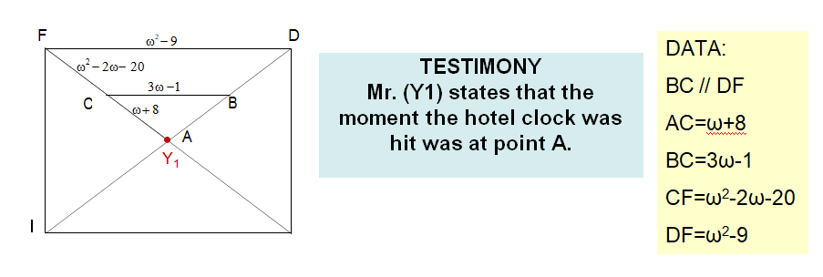

SOLUTION - ANSWER
The triangles ABC and ADF are similar, so AC/AF = BC/DF
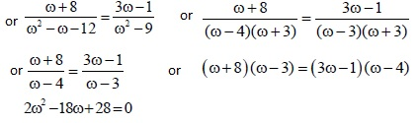
and the solutions are:
ω = 2 which is discarded because AF = -10
or ω = 7 which is accepted.
So AF = 30 meters, so Mr. Y1 can not be the killer.

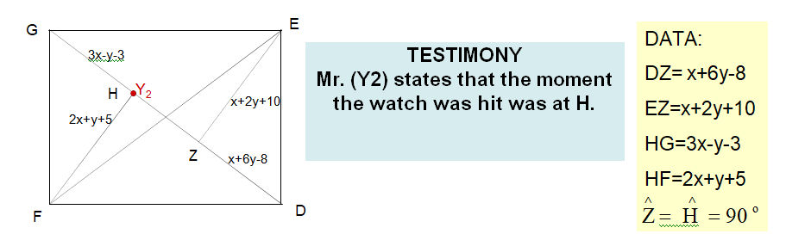
SOLUTION - ANSWER

The triangles of HGF and DEZ are equal, so HG= DZ and HF = EZ
3x-y-3 = x + 6y-8 and 2x-7y = -5 and 2x-7y = -5 and
2x + y + 5 = x + 2y + 10 x-y = 5 x = y + 5
2 (y + 5) -7y = -5 and 2y + 10-7y = -5 and -5y = -15 and
x = y + 5 x = y + 5 x = y + 5
So y = 3 and x = 8
So HF = 24 meters, so Mr. Y2 can not be the killer.

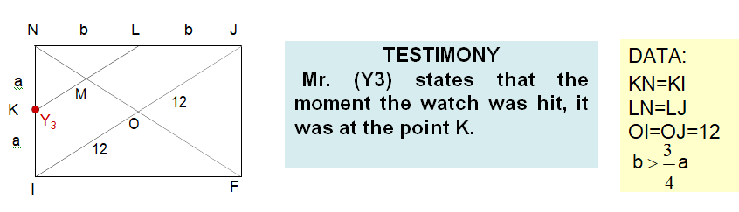
SOLUTION - ANSWER
Let us calculate the route KM + MF.
It is KL // JI, because K and L are the means of the sides NI and NJ of the triangle JNI.
M is the mean of NO, since in the ONI triangle K is a means of NI and KM // OI.
We conclude KM – OI/2 = ML because in the NOJ triangle M is the mean of NO and also holds OI = ΟJ (the diagonals of the parallelogram are divided)
We have ΝΜ = ΚΜ = LM, since the triangle ΚΝL is rectangular and the NM the median.
Therefore: KM + MF = ΝΜ + ΜF = NF = JΙ = 24 (the diagonals of a rectangle are equal).
We have to prove that the shortest route from point K to point F is ΚΜ + ΜF = ΝF and not ΚΙ + ΙF.
It is NF = SQRT (2a² + 2b²) from the Pythagorean Theorem in the FNI triangle.
It is enough to prove KI + ΙF > NF, ie a + 2b > SQRT (2a² + 2b²)
We amplify in square (a + 2b)² > (2a)²+ (2b)² or a² + 4ab + 4b²> 4a² + 4b² or 4ab> 3a² or b > ¾ a which is valid.
Eventually the shortest route that Mr Y3 could follow is KM + MF = 24 meters, so it can not be the killer.

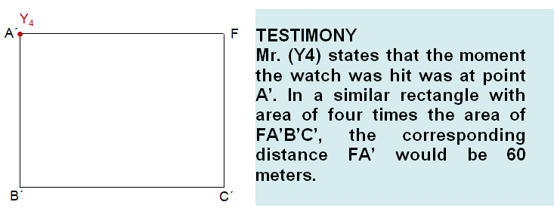
SOLUTION - ANSWER

If we call E the real area of the rectangle and E’ the area that would have its similar rectangle, then it will apply
E/E’ = (d/d’)²
because the ratio of the areas of two similar shapes is equal to the square of their similarity ratio
E/4E = (d / 60)² or 1/4 = (d / 60)² or 1/2 = d/60 or eventually d=30
So Mr. Y4 cannot be the killer.

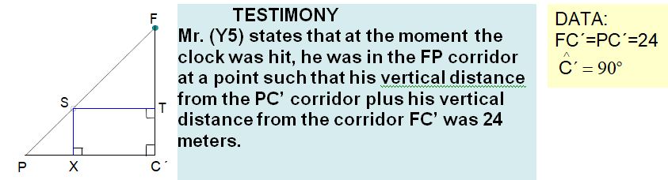

SOLUTION - ANSWER
We consider a random point S on the FP side.
We bring the ST vertical to the FC’ and the SX vertical to the the PC’.
It is angle F=45º since the triangle FPC’ is rectangular and isosceles.
It is angle FST=45º because in triangle FST is angle F=45º and angle T=90º
Here comes ST = FΤ (1) (the triangle FST proved to have two equal angles and therefore is isosceles).
It also follows that SΧ = ΤC’ (2) (XSTC’ is a rectangle).
From (1) and (2) it follows: SΤ + SΧ = FΤ + ΤC’ = ΦC’ = 24.
This means that the point S can be any point on the FP side. That is, it may be a point that is farther away than the point F of more than 20 meters, for example the point P or a point that is far from the point F, less than 20 meters, for example the point F.
So Mr. Y5 cannot be described as innocent or guilty.

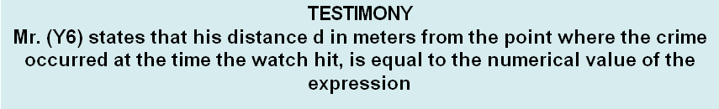
for x = 5/3

SOLUTION - ANSWER
We make the division of the polynomials and from the identity of the division we get:
Therefore, the expression d (x) becomes:
So, then
So Mr. Y6 cannot be the killer.

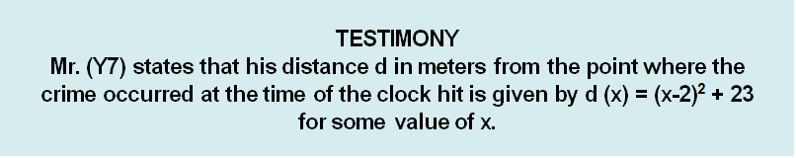

SOLUTION - ANSWER
Expression d for x = 2 gives the lowest value
Since x-2 becomes 0 whereas for every other value of x the (x-2)² becomes positive
So the expression for x = 2 takes the value 23
So Mr. Y7 cannot be the killer, since the lowest value of the expression is 23 and then Mr. Y7's distance from the point F is greater than or equal to 23 meters.

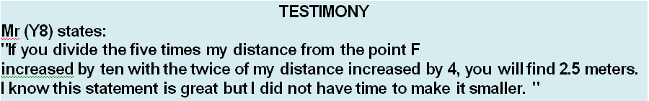

SOLUTION - ANSWER
If d is the distance will apply (5d+10)/(2d+4) = 2,5 or 5d+10=2,5(2d+4) or 5d+10=5d+10, so the equation is indefinite.
Therefore distance d can be any positive number.
So we cannot conclude if Mr. Y8 is innocent or guilty, since we basically do not know his distance from the point F.

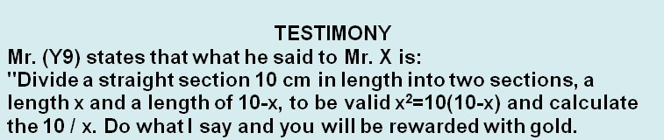

SOLUTION - ANSWER
The equation x² = 10(10-x) becomes x² + 10x-100 = 0, which has a positive root number
Then ,which is the number φ of the golden ratio and in any artistic creation we meet this number and it gives us a sense of harmony and beauty.
So the gold promised Mr. Y9 was the gold number φ, so we cannot blame him as guilty.

TESTIMONY
Mr. (Y10) says he knows who killed Mr. X.
"Mr (Y7) lied to you.
He killed Mr. X!
We are both French and I know the French well, they are all liars.

SOLUTION - ANSWER
If Mr. Y10 tells the truth that the French are lying, then because himself is a Frenchman he is lying that he knows the murderer.
If Mr. Y10 is lying that the French are lying, then we conclude that the French are telling the truth, and because Mr Y10 is French, what he says it is true.
That is, if Mr. Y10 says truth, then he is lying, and if he is lying, then he says true.

